**Quiz 9**

**DSCI 558 BUILDING KNOWLEDGE GRAPH**

Name: ________________________________________________

## Question 1 (7 pts)

In Snorkel, which of the following statements is correct? (LF = Labeling Function)

__F__ Snorkel generative models assume that the labeling functions make independent labeling decisions

__F__ We would rather have no conflict between the labeling functions’ output

__F__ The generative model is an equal majority-vote model of the labeling functions

__T__ The final discriminative model is trained with a set of probabilistic training labels

__T__ The final discriminative model learns a feature representation of the LFs

__T__ Distant supervision LFs can use existing knowledge graphs of known­ facts to generate noisy labels

__F__ In the generative training, accuracies of LFs are optimized using labeled data

__F__ In Snorkel, structure learning is used to create new LFs by combining existing LFs

__T__ Snorkel maximizes the marginal likelihood of the LFs to learn parameters

**Question 2 (3pts)**

Given the following sentences and two labeling functions to detect married couples:

1. Return True if people with the same last names. Otherwise, return False
2. Return True if the couple is (“Barack Obama”, “Michelle Obama”). Otherwise, return False

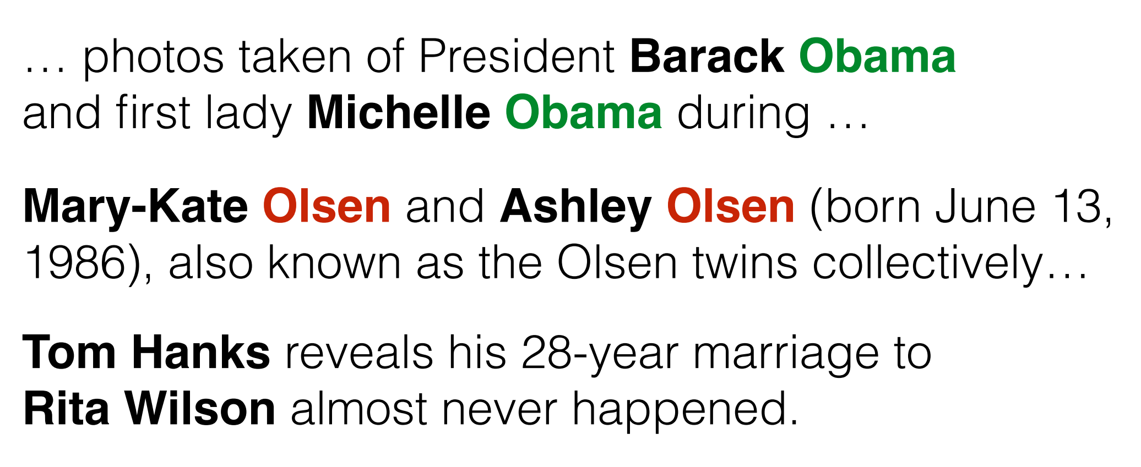

LF1: accuracy = 1/3

LF2: accuracy = 2/3

Coverage = 1

Conflict = 1/3